1. **Alter Table:**

Q1) Add a new column linkedin_profile to employees table to store LinkedIn URLs as varchar.

Query:

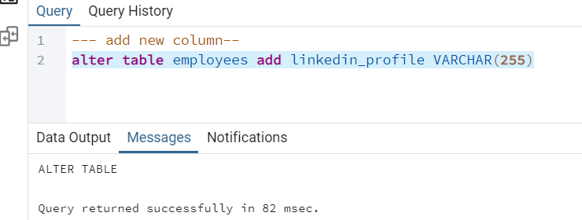

Output:

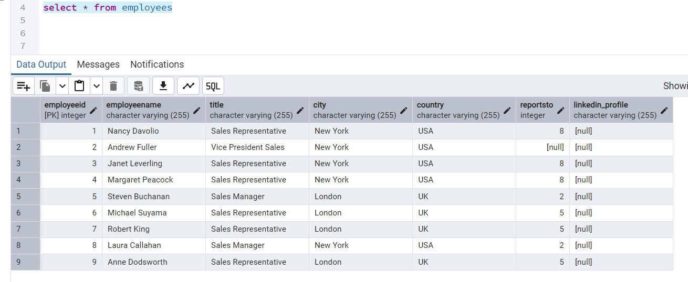

Q2) Change the linkedin_profile column data type from VARCHAR to TEXT.

Query:

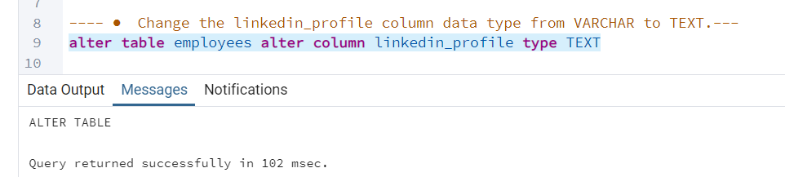

Output:

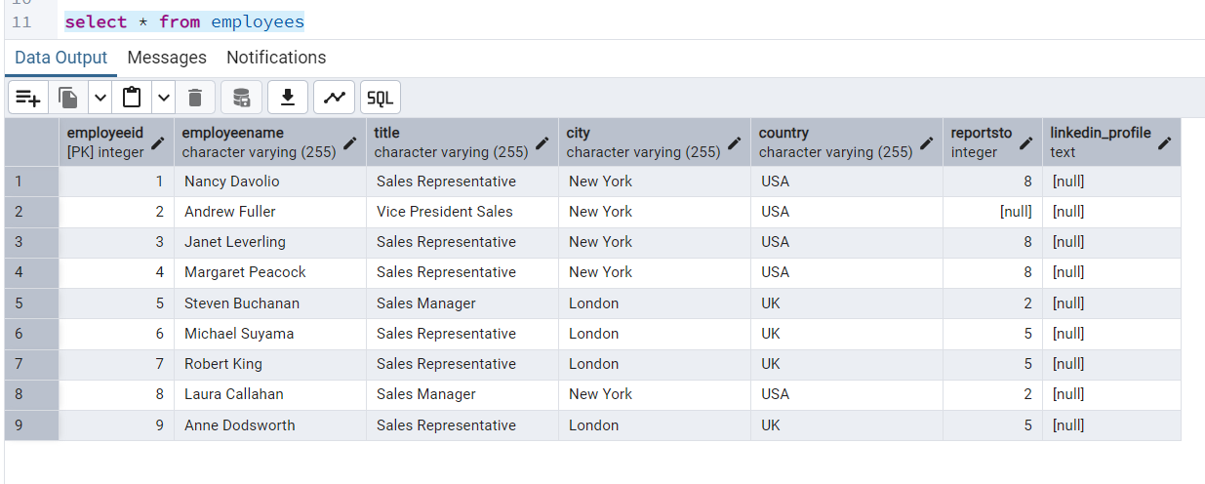

Q3) Add unique, not null constraint to linkedin_profile

Query:

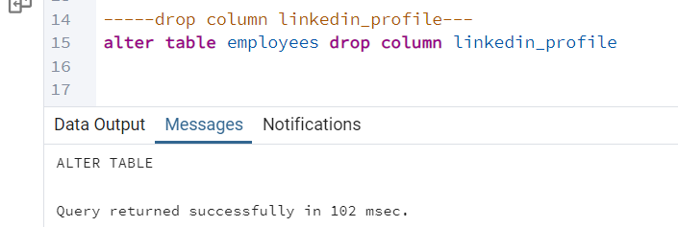

Output:

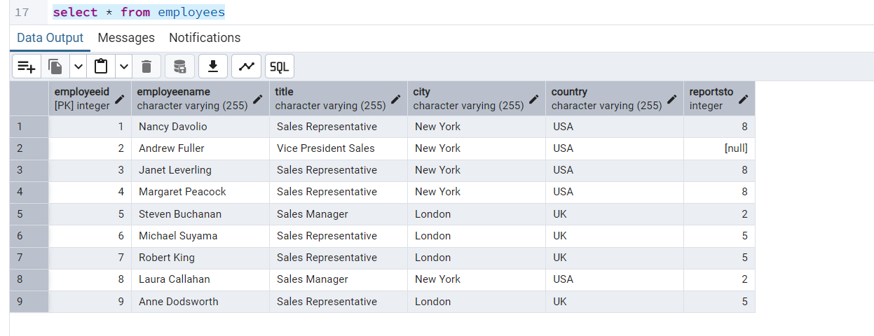

**2) Querying (Select)**

Q1) Retrieve the employee name and title of all employees, and title of all employees

Query:



Output:

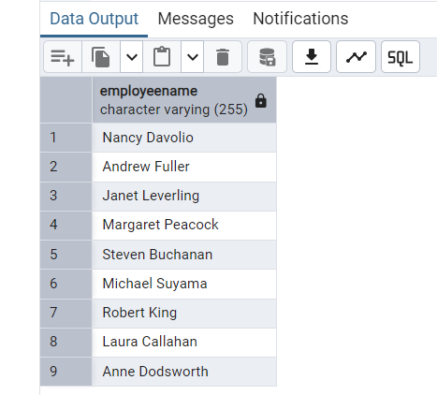

Q2) Find all unique unit prices of products

Query:

select distinct unitPrice from products

Output:

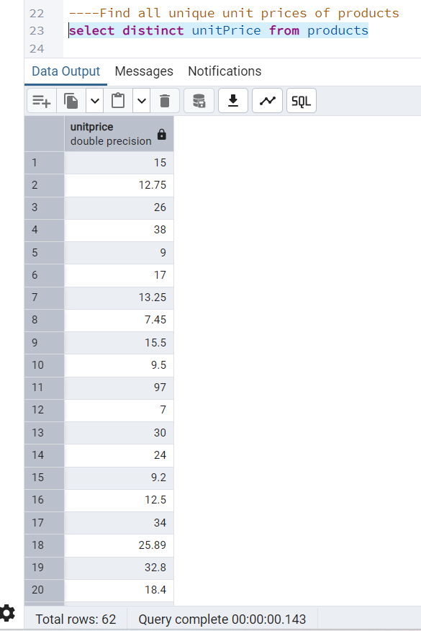

Q3) List all customers sorted by company name in ascending order

Query:

select * from customers order by companyName asc;

Output:

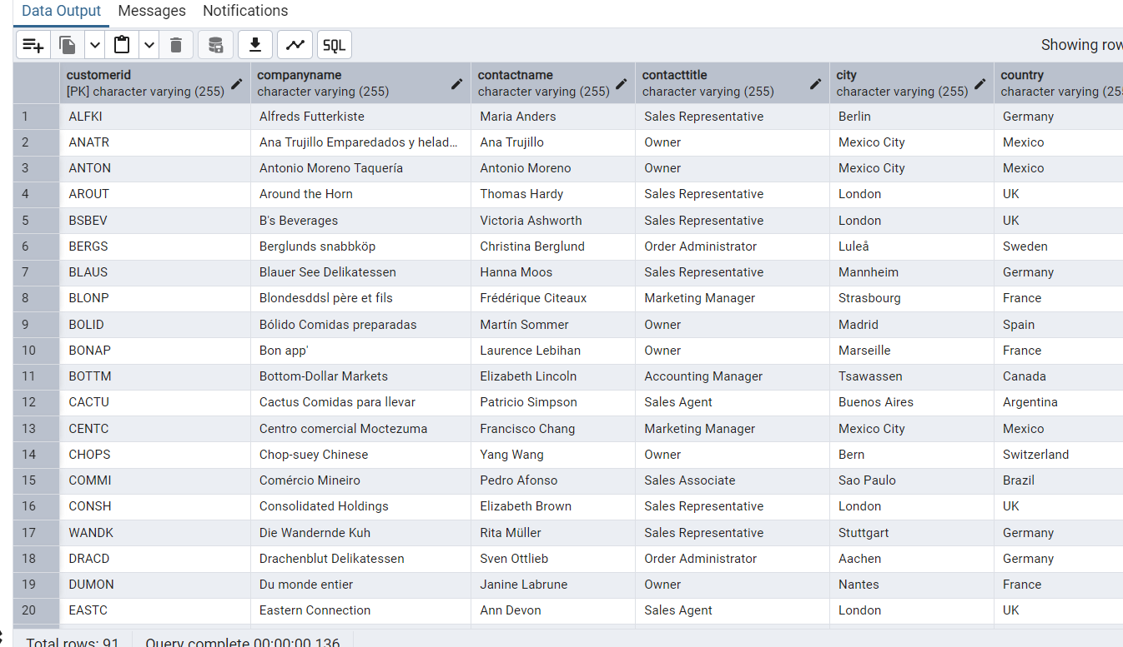

Q4) Display product name and unit price, but rename the unit_price column as price_in_usd

Query:

alter table products rename column unitPrice to price_in_usd

select productName, price_in_usd from products

Output:

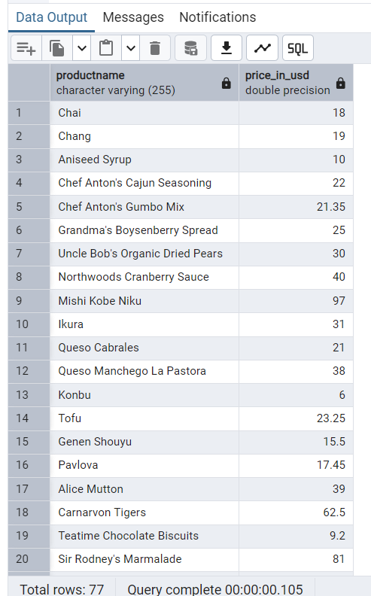

**3) Filtering**

Q1) Get all customers from Germany.

Query:

select * from customers where country= 'Germany'

Output:

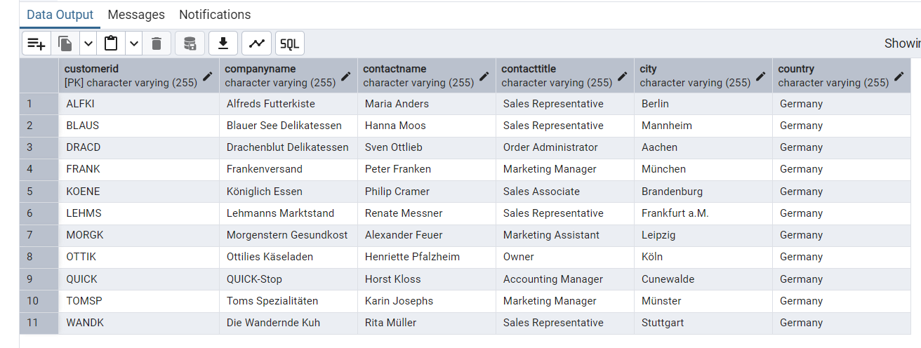

Q2) Find all customers from France or Spain

Query:

select * from customers where country = 'France' or country='Spain'

Output:

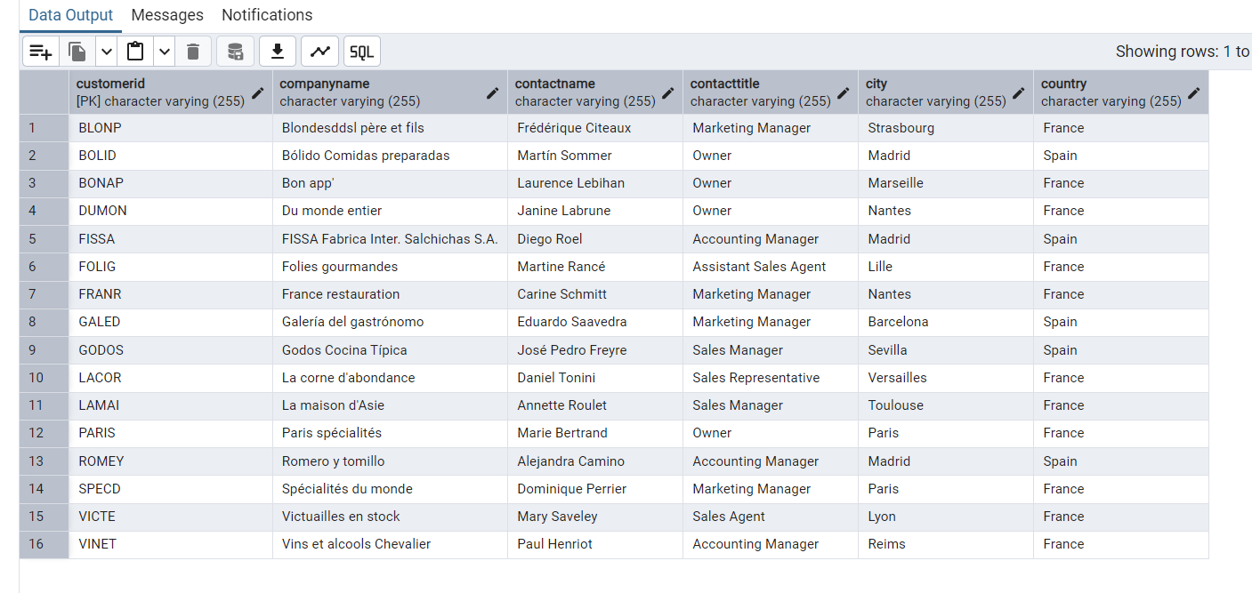

Q3) Retrieve all orders placed in 2014(based on order_date), and either have freight greater than 50 or the shipped date available (i.e., non-NULL) (Hint: EXTRACT(YEAR FROM order_date))

Query:

select * from orders where (date_part ('year', orderDate) = 2014) and (freight > 50 or shippedDate is not null)

Output:

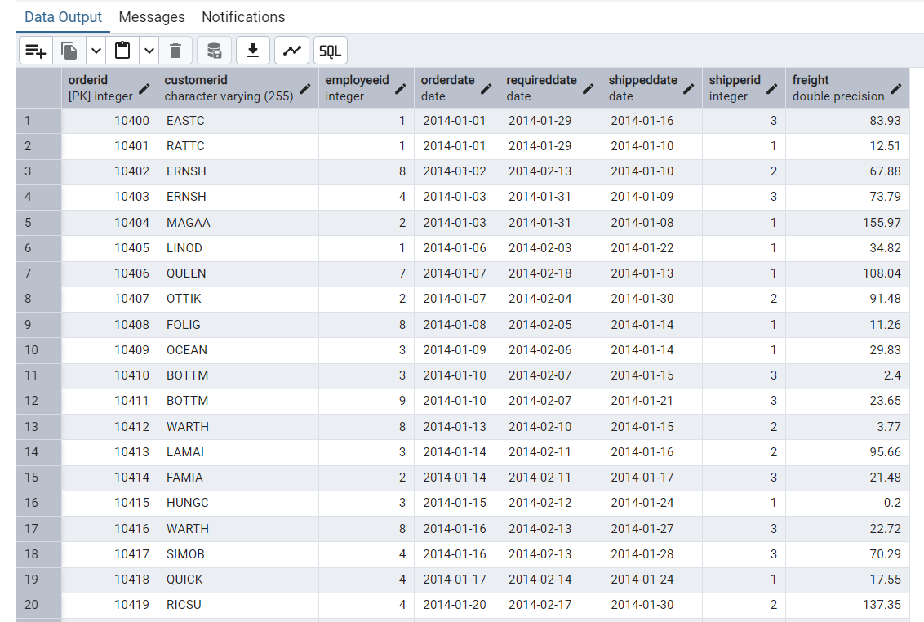

**Filtering**

**Q1)** Retrieve the product_id, product_name, and unit_price of products where the unit_price is greater than 15.

Query:

Select productID, productName, price_in_usd from products where price_in_usd > 15

Output:

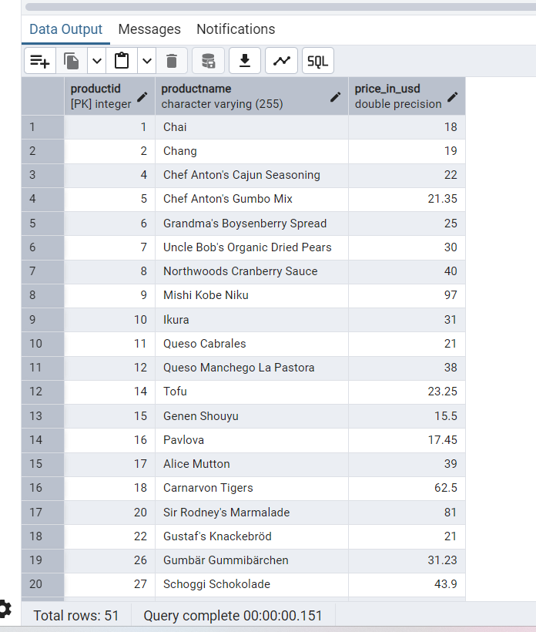

Q2) List all employees who are located in the USA and have the title "Sales Representative".

Query:

select * from employees where country= 'USA' and title='Sales Representative'

Output:

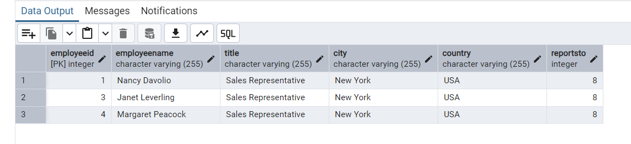

Q3) Retrieve all products that are not discontinued and priced greater than 30.

Query:

select * from products where discontinued = 0 and price_in_usd > 30

Output:

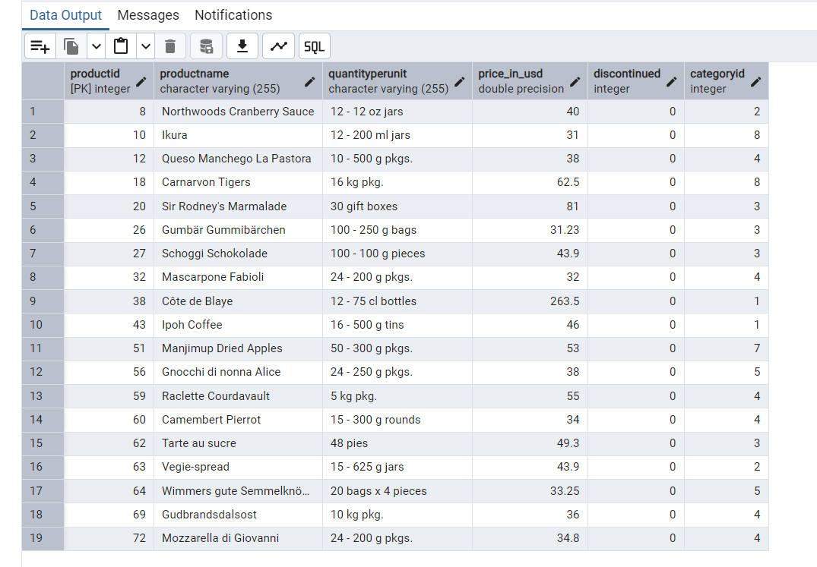

**5) LIMIT/FETCH**

Q1)Retrieve the first 10 orders from the orders table

Query:

select * from orders limit 10

Output:

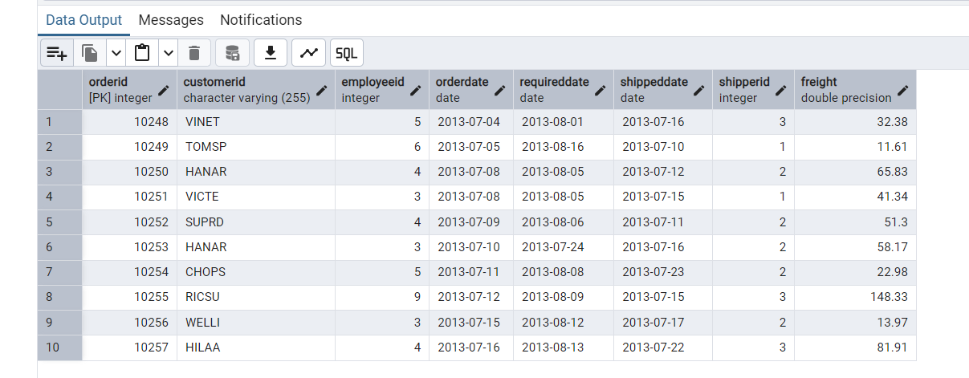

Q2) Retrieve orders starting from the 11th order, fetching 10 rows (i.e., fetch rows 11-20).

Query:

select * from orders limit 10 offset 10

Output:

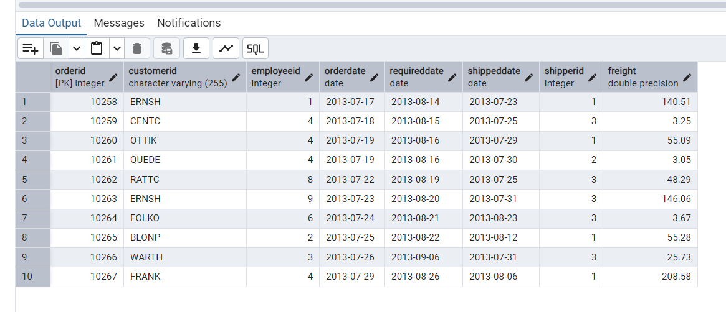

**6) Filtering (IN, BETWEEN)**

**Q1)** List all customers who are either Sales Representative, Owner

Query:

select * from customers where contacttitle= 'Sales Representative' or contacttitle= 'Owner'

Output:

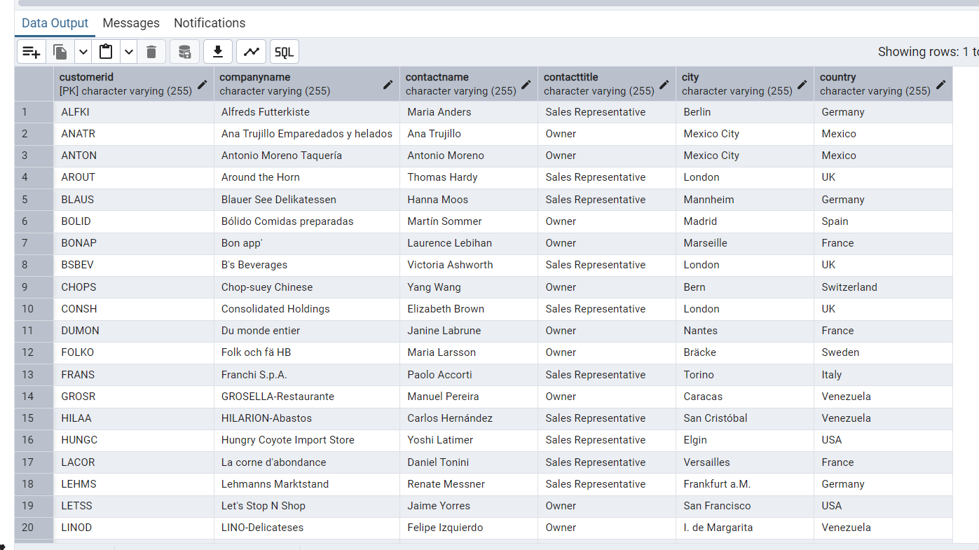

Q2) Retrieve orders placed between January 1, 2013, and December 31, 2013.

Query:

select * from orders where orderdate between '2013-01-01' and '2013-12-31'

Output:

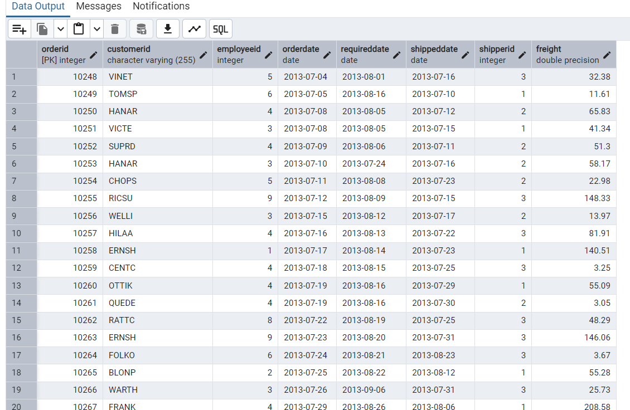

**Filtering**

**Q1)** List all products whose category_id is not 1, 2, or 3.

Query:

select * from products where categoryid not in (1,2,3)

Output:

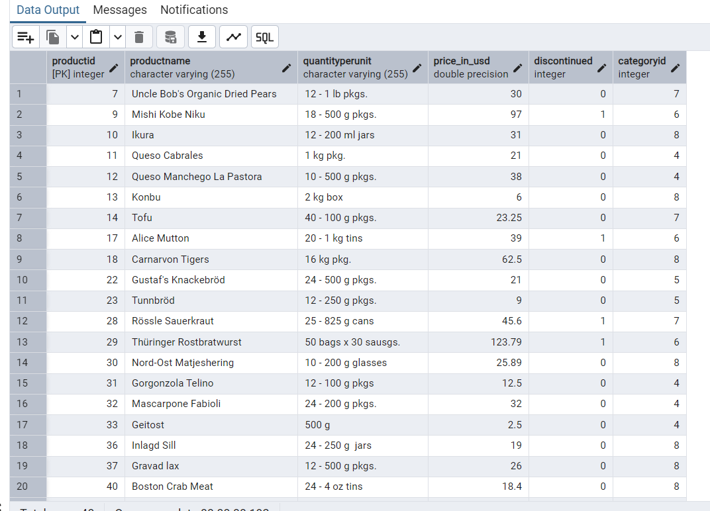

Q2) Find customers whose company name starts with "A".

Query:

select * from customers where companyname like 'A%'

Output:

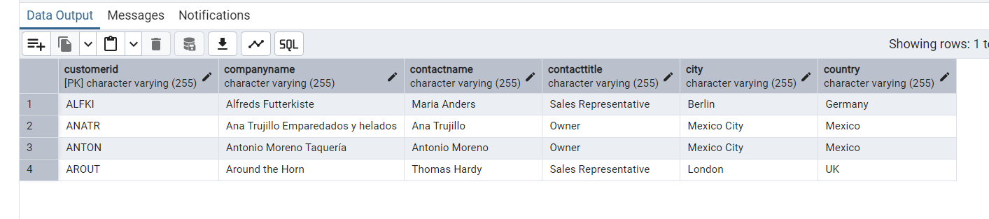

8) INSERT into orders table:

Task: Add a new order to the orders table with the following details:

Order ID: 11078

Customer ID: ALFKI

Employee ID: 5

Order Date: 2025-04-23

Required Date: 2025-04-30

Shipped Date: 2025-04-25

shipperID:2

Freight: 45.50

Query :

insert into orders(orderid,customerid,employeeid,orderdate,requireddate,shippeddate,shipperid,freight) values (11078,'ALFKI',5,'2025-04-23','2025-04-23', '2025-04-23',2,45.50)

Output:

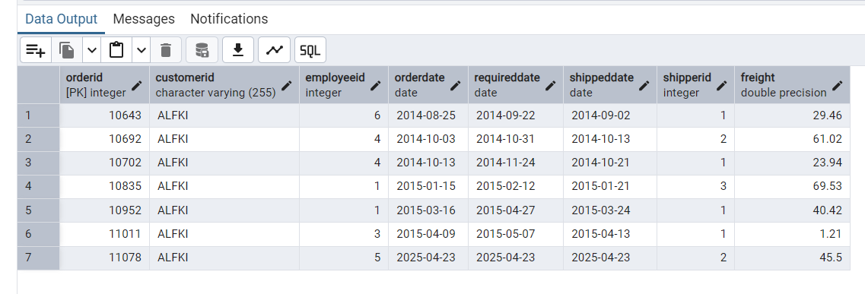

9) Increase(Update) the unit price of all products in category_id =2 by 10%.

(HINT: unit_price =unit_price * 1.10)

Query:

update products set price_in_usd = price_in_usd+((price_in_usd +10)/100) where categoryid=2

Output:

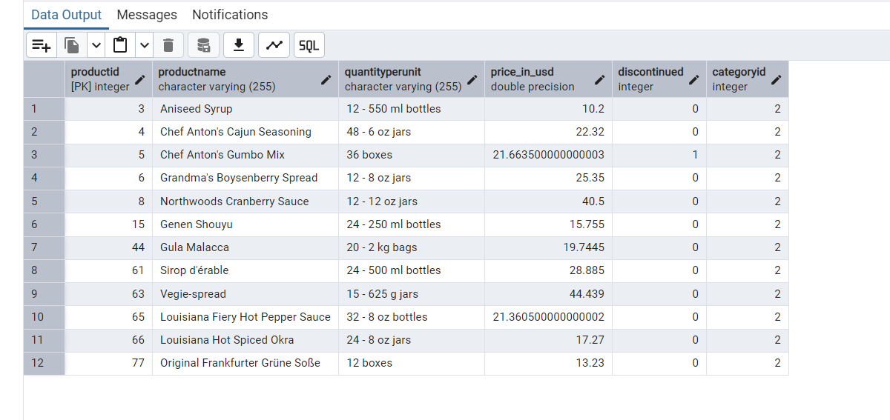

10) Sample Northwind database

